**BFS**

DFS

DLS Limit=2

**IDS**

**BFS Goal=92**

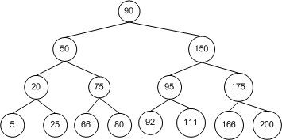

**DFS Goal=66**



**DLS Goal=25 Limit=2**



**IDS Goal=80**



**BFS - L**



**DFS - L**



**UCS**

